Design Document
Trust Director
Version 0.1
Authors: Boski Shah, GSLab

Table of Contents
1. Introduction and Overview 3
Use cases 3
Functional Requirements 8
Performance Requirements 9
2. Detailed Design 10
A. Swift Integration 10
Trust Director 10
Policy Agent 18
B. Asset tag 18
Workflow 18
Trust Director 19
Openstack Scheduler Filter 21
VRTM 21
Attestation Server 21
3. Security Threats and Mitigation 21
4. Opens 21

Version | Change | Editor | Date
0.1 | Initial version with detailed design and flow | Boski Shah, GS lab | 02/25/2015
Table 1 Version History

- Introduction and Overview
This document captures details about Trust Director usecases added after RC1 release in CIT solution. If other components of CIT are affected by features mentioned here, design of those components is also covered as a part of this document. Please refer CIT user guide and System design document to get further details on Trust Director and other components of CIT.

Use cases
Use Case ID | CIT-tdes-001
Title | Add/Update/Delete external storages glance/swift
Summary | User will setup external storages glance and/or swift from trust director
Pre-conditions | External storages are setup and credentials required to be used by director are created.
System state | Director is installed and running
Basic course of events | Add store:  - User selects store type to be added  - User provides required credentials  - Director validates all credentials by connecting to store  - Director adds store  Update Store:  - User selects store to be updated  - Director updates values  - Director will validate new values and save it permanently  Delete Store:  - User selects store and deletes it  - Director asks confirmation before actually deleting it
Post-conditions | External storage settings will be updated in director
Alternate paths | NA
Exceptions | If director cannot connect to external storage using provided credentials it will not update the store.
Extension Points | None
Business Rules | External store credentials should not be shared with non CIT component or operator to restrict an attacker to read the policy
Opens | Currently compute node supports configuration of just one swift and so director, we need to determine if multiple swifts need to be configured
Author, Date, Version | Boski Shah, Feb 25, 2016

Use Case ID | CIT-tdsw-002
Title | Upload trust policy to swift
Summary | Allow user to upload policy in swift and image in glance
Pre-conditions | Glance and swift image stores are setup in director
System state | CIT components are running  External storages are ready to be used
Basic course of events | - User creates policy  - User chooses to upload image(if not uploaded) in glance and policy in swift  - Director uploads image and policy and setup image properties in glance which has details on policy location
Post-conditions | Image is uploaded in glance  Policy is uploaded in swift and it has a unique URL using which we can download policy
Alternate paths | User can upload image and policy both in glance as a tarball
Exceptions | If image upload to glance fails policy will not be uploaded to swift
Extension Points | None
Business Rules | Image must be uploaded first and then policy
Opens | None
Author, Date, Version | Boski Shah, Feb 25, 2016

Use Case ID | CIT-tdsw-003
Title | Update trust policy
Summary | User updates policy using director and stores updated policy in swift
Pre-conditions | Image is already uploaded in glance and is not deleted. Policy is also uploaded in swift/glance.
System state | Director is running  External storages are ready to be used
Basic course of events | - Edit trust policy using director  - User selects an option to upload just policy  - User selects swift where policy will be uploaded  - If policy was previously stored on swift replace it with new policy  - If policy was uploaded in glance create new policy in swift and map it with image in glance using image properties
Post-conditions | Image is uploaded in glance  Policy is uploaded in swift and it has a unique URL using which we can download policy
Alternate paths | User can upload image and policy both in glance as a tarball
Exceptions | If image upload to glance fails policy will not be uploaded to swift
Extension Points | None
Business Rules | Image must be uploaded first and then policy
Opens | None
Author, Date, Version | Boski Shah, Feb 25, 2016

Use Case ID | CIT-cnsw-004
Title | Compute node downloads trust policy from swift
Summary | Compute node gets URL of trust policy from image properties and download policy using the URL
Pre-conditions | Compute node is configured to have access to swift
System state | Openstack environment is running  Compute node is running
Basic course of events | - User uploads image in glance and policy in swift using director  - User launches instance using openstack  - Launch request comes to compute node where it grapes policy URL from image properties  - Compute node downloads policy from swift using URL and continues launch process
Post-conditions | Compute node validates image and system state against policy and continues/abort launch process
Alternate paths | User can upload image and policy both in glance as a tarball so compute node does not need to download policy separately from swift
Exceptions
Extension Points | None
Business Rules | Image ID in policy and image ID in glance must match to assure that policy is associated with image.
Opens | None
Author, Date, Version | Boski Shah, Feb 25, 2016

Use Case ID | CIT-tdsw-005
Title | Delete unused policy from swift
Summary | If image is deleted from glance, there is no way that swift gets notified of that action so director will provide an option to user to delete unused policies from swift.
Pre-conditions | Director has access to delete policies from swift
System state | Director is running  Openstack environment is running
Basic course of events | - On director UI, user clicks a button to cleanup policies  - Director ask for confirmation to the user  - Director calculates unused policies and deletes all
Post-conditions | All policies in swift have associated image in glance
Alternate paths

Exceptions
Extension Points | None
Business Rules | Image ID in policy and image ID in glance must match to assure that policy is associated with image.
Opens | None
Author, Date, Version | Boski Shah, Feb 25, 2016

Table 2 use case 2 CIT-Director-Asset-tag

Use Case ID | CIT-tdat-006
Title | Manage(create/update/delete) Asset Tags
Summary | Using director user manages asset tags in form of key value pair in director’s database
Pre-conditions
System state | Director is installed
Basic course of events | - User creates/updates/deletes asset tags using director  - Director saves updated tags in the director database
Post-conditions
Alternate paths | User can use APIs or UI to manage tags
Exceptions
Extension Points | None
Business Rules | Admin is responsible to sync up tags between Director and Attestation Server
Opens | Need to assign roles who can manage tags from UI
Author, Date, Version | Boski Shah, Feb 29, 2016

Use Case ID | CIT-tdat-007
Title | Export Tags
Summary | User can export all tags saved in director in form of XML
Pre-conditions
System state | Director is installed
Basic course of events | - User exports tags using UI or API  - All tags stored in director are returned in form of XML
Post-conditions
Alternate paths | User can use UI or APIs to export tags
Exceptions
Extension Points | None
Business Rules
Opens

Author, Date, Version | Boski Shah, Feb 29, 2016

Use Case ID | CIT-tdat-008
Title | Add Asset tags in Trust Policy
Summary | User can associate tags with docker/vm image and add it to trust policy
Pre-conditions | Tag attributes should already be created in director
System state | Director is installed
Basic course of events | - While creating trust policy user selects to add asset tags in trust policy  - User can add at max five tag attributes in policy  - User uploads image in image store  - Director updates image properties and adds tags to it
Post-conditions | The asset tags should be mapped as image properties once image is uploaded to image store
Alternate paths | Use can associate asset tags with image from Horizon dashboard
Exceptions
Extension Points | None
Business Rules
Opens | Shall we remove horizon extensions to add tags
Author, Date, Version | Boski Shah, Feb 29, 2016

Use Case ID | CIT-tdat-009
Title | Add location and boundary control in trust policy
Summary | Add location and boundary control option in trust policy to decide whether to launch VM/Docker on trusted host or not
Pre-conditions
System state | Entire CIT should be up and running
Basic course of events | - User chooses to select or deselect location and boundary control in trust policy
Post-conditions | Location and boundary control is set as image properties while image is uploaded to glance
Alternate paths | Use can associate location and boundary control with image from Horizon dashboard
Exceptions
Extension Points | None
Business Rules
Opens | Shall we remove horizon extensions related to setting location and boundary control
Author, Date, Version | Boski Shah, Feb 29, 2016

Use Case ID | CIT-osat-010
Title | Openstack scheduler should read image properties and schedule host accordingly
Summary | Openstack scheduler should read tags and location and boundary control from image properties set by director and picks up host accordingly
Pre-conditions | Asset tags and location and boundary control is set by director
System state | Entire CIT should be up and running
Basic course of events | - User launches image from horizon  - Scheduler reads tags and location and boundary control from image properties and schedules host to launch image accordingly
Post-conditions
Alternate paths

Exceptions
Extension Points | None
Business Rules
Opens

Author, Date, Version | Boski Shah, Feb 29, 2016

Use Case ID | CIT-vrtmat-011
Title | VRTM should verify asset tags and location and boundary control
Summary | VRTM should be updated to verify new tags added in trust policy 1) asset tag 2) location and boundary control
Pre-conditions | Asset tags and location and boundary control is set by director
System state | Entire CIT should be up and running
Basic course of events | - User launches image from horizon  - Scheduler schedules host to launch image  - VRTM verifies entire trust policy and decides to continue launch
Post-conditions
Alternate paths

Exceptions
Extension Points | None
Business Rules
Opens

Author, Date, Version | Boski Shah, Feb 29, 2016

Functional Requirements

Usecase ID | Requirement ID | Description | Priority
CIT-tdes-001 | Fr-td-swift-001 | Allow user to add swift and glance as an external storage. | High
CIT-tdes-001 | Fr-td-swift-002 | - User should be able to add multiple glance and just one swift. | High
CIT-tdes-001 | Fr-td-swift-003 | Director should validate store credentials before adding it to director | High
CIT-tdes-001 | Fr-td-swift-004 | Allow user to update swift and glance external storage. | High
CIT-tdes-001 | Fr-td-swift-005 | Allow user to delete swift and glance external storage. | High
CIT-tdsw-002 | Fr-td-swift-006 | Allow user to upload policy in swift  Update glance image properties cit_trustpolicy_location to swift:<Object URL> | High
CIT-tdsw-003 | Fr-td-swift-007 | user should be able to update policy stored in swift only if uploaded image is compatible with updated policy (dek url should match). | High
CIT-tdsw-003 | Fr-td-swift-008 | If user has policy in glance and he wants to update policy he should be allowed to add new policy in swift and update cit_trustpolicy_location | High
CIT-cnsw-004 | Fr-td-swift-009 | Compute node installer should be updated to configure swift | High
CIT-cnsw-004 | Fr-td-swift-010 | Policy agent should be able to determine trust policy location from image properties and download policy from glance/swift | High
CIT-tdsw-005 | Fr-td-swift-011 | TD UI should provide an option to delete policy in swift if respective image is deleted from glance | High
CIT-tdat-006 | Fr-td-at-012 | User should be able to create tag attributes from director | High
CIT-tdat-006 | Fr-td-at-013 | User should be able to export all tag attributes defined in director | High
CIT-tdat-006 | Fr-td-at-014 | User should be able to add tags in trust policy. Trust policy can have maximum five attributes | High
CIT-tdat-006 | Fr-td-at-015 | Director should set tags in image properties while uploading image to glance | High
CIT-tdat-006 | Fr-td-at-016 | Allow user to select platform trust option and add it to trust policy | High
CIT-tdat-006 | Fr-td-at-017 | VRTM should verify tags in policy against one provisioned in TPM | High
CIT-tdat-006 | Fr-td-at-018 | VRTM needs to implement caching mechanism as MTW to cache SAML report periodically | Medium
CIT-tdat-006 | Fr-td-at-019 | VM Attestation API needs to be updated to verify assettag and platform trust | High
Table 3 Functional Requirements

Performance Requirements

Requirement ID | Description | Priority
TD-uploadSwiftPolicy | TD should not suffer significant slowdown while uploading policy to swift | Medium
PA-downloadSwiftPolicy | PA should not suffer significant slowdown while downloading policy from swift | Medium
VRTM-cacheSaml | Compute node should not suffer significant slowdown while getting provisioned tags | Medium
Table 4 Performance Requirements

Component | Ownership
TD, PA | GSL
Installer | GSL
Testing and Validation | CIIT engineering
Table 5 Component Ownership information (Leads: Boski and Sudhir)
- Detailed Design

A. Swift Integration
Here we will discuss about changes required in each CIT components to support swift integration feature

Trust Director

Workflow
- User will create new external storage of type swift.
- User will create trust policy for a particular image.
- Director will allow user to upload/update policy in swift
- user will upload/update policy in swift
Director will supports following upload options:
- Upload image only
The user uploads the image without its policy to the image store-Glance. An entry is made into MW_IMAGE_UPLOADS table for this upload. The upload_var column is set to a value of the MD5sum of the UUID of the image.
- Upload Tarball
Similar to above. In addition an entry is made in the MW_POLICY_UPLOAD table.
- Upload image with policy
In this case an entry is made in the MW_IMAGE_UPLOAD and MW_POLICY_UPLOAD with the urls pointing to the respective artifact.
Also the UPLOA_VAR column is populated with the value = MD5sum of (UUID of image and the DEK URL if present)
- Upload policy after image/tar upload
The pre-condition for policy upload is that:
- Image for the policy should already be uploaded to glance
- the upload_var for the uploaded image should match the upload_var for the policy
If there are nulpiple uploads of same image, user should get option to update for last uploaded image only.

Assumptions:
- Image has to be uploaded first before updating/uploading policy in swift
- If there are mupltiple uploads of same image and user wants to update policy, director will provide an option to update policy of only last uploaded image only not previous ones.

UI changes
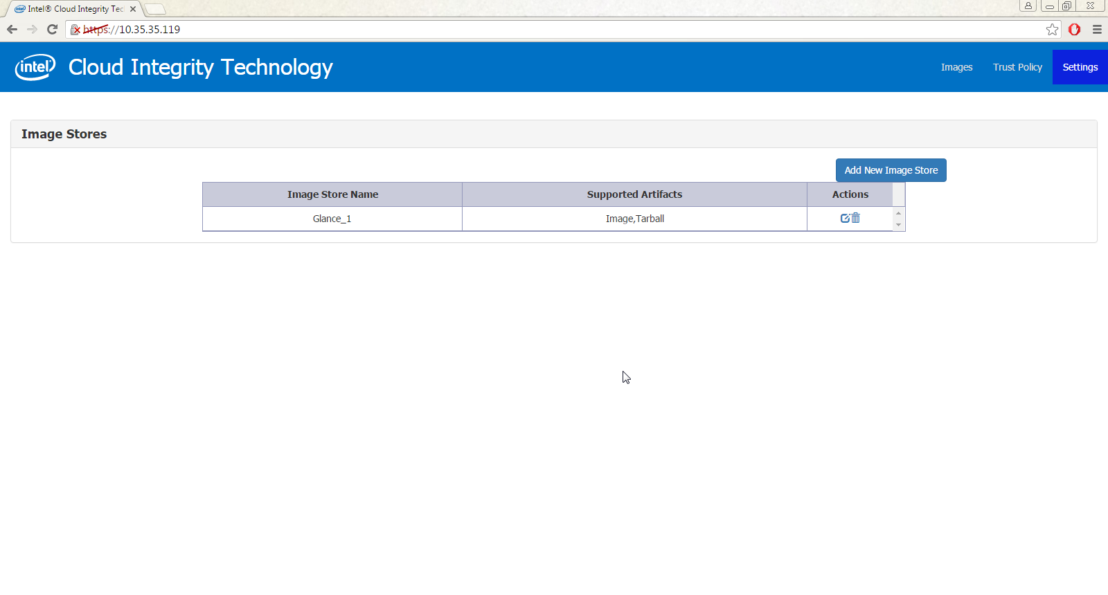
List External Storages

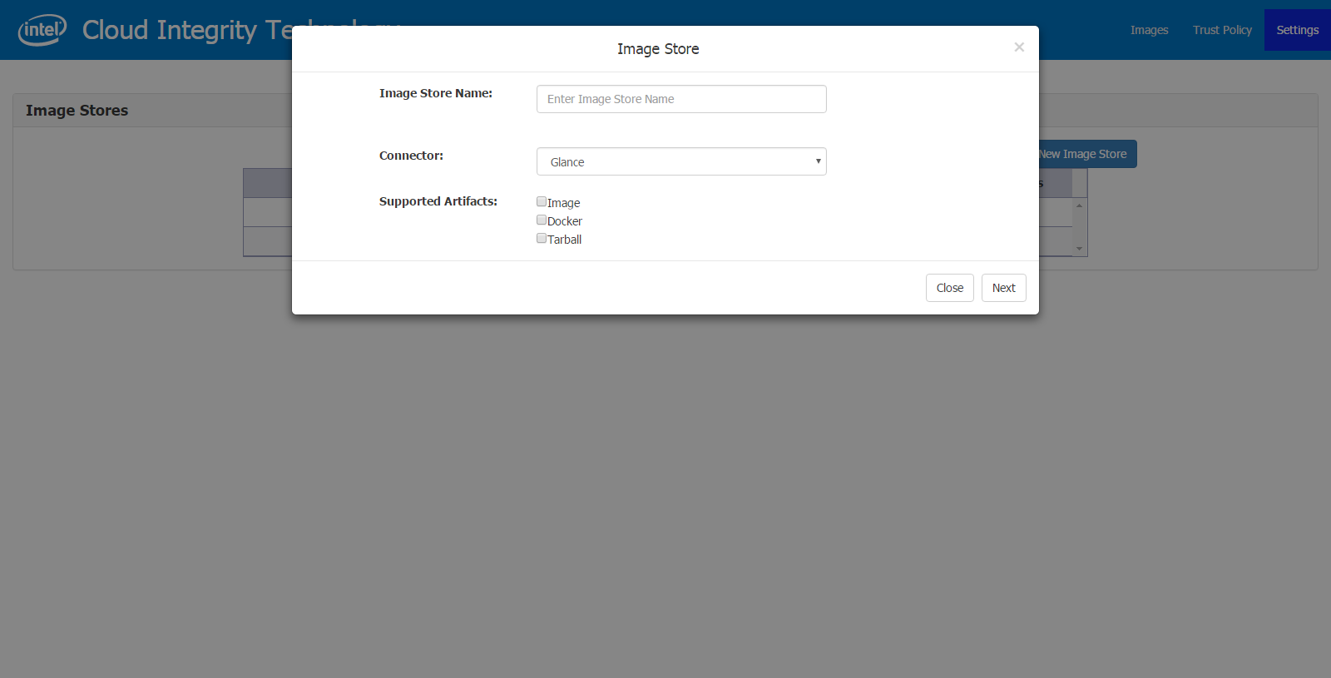
Create new external storage

The user should provide a name and select the type of store. The list of available stores are:
a) Glance
b) Swift
c) Docker
Depending on the selected connector, the user can choose the artifact that can be uploaded to the store.
These artifacts are also configured by TD. So far
a) Glance: Image, Tar, Docker image
b) Swift: Policy
c) Docker: Docker image/Tarball

Add the details of the connector

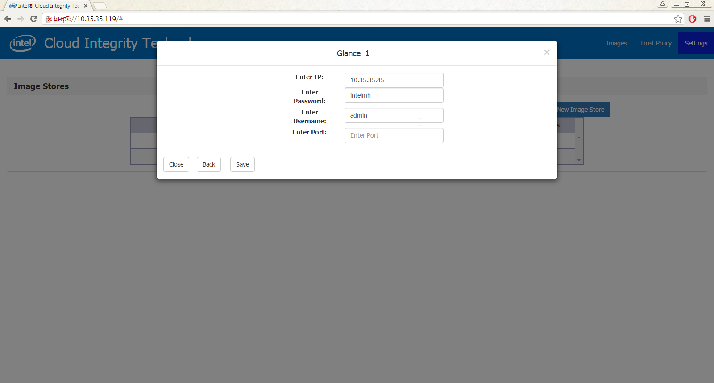
The user provides the configurations that are required by the connectors.

Validation of the Image Store
The image store that is configured can be validated in 2 ways:
- When the store is being configured and saved. An example is below where the tenant name is invalid
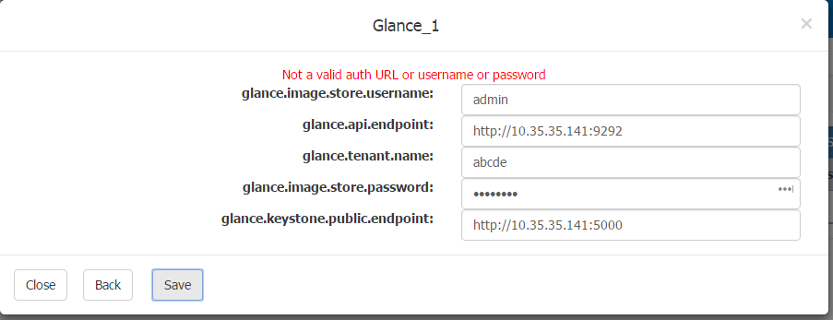
- After the image store is created, from the image stores grid page
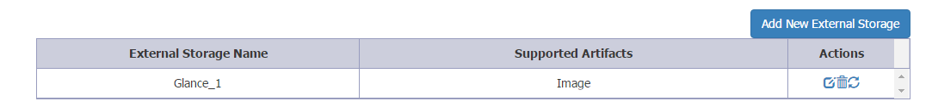
Director has a refresh icon in addition to the edit and delete icons. Clicking on the icons will call out the validation API and change the icon to a tick or an X, depending on the result.
Invalid image store configuration

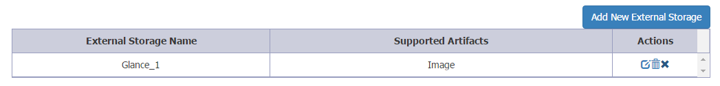

Valid image store configuration
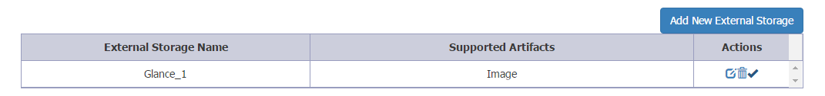
Choose artifact to be uploaded from TD
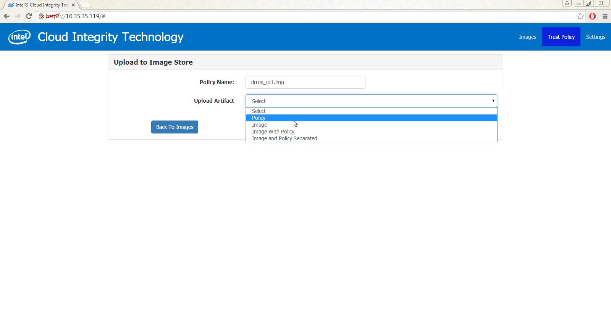
A sample URL by which an object/policy is identified in Swift is :
http://Controller:8080/v1/AUTH_a4bde8b572054869848712dc9bd262ea/TD_Container/e683c3d3-c4c3-4ca3-80d8-a833528e6d60
where :
Account - AUTH_a4bde8b572054869848712dc9bd262ea
Container - TD_Container
Object - e683c3d3-c4c3-4ca3-80d8-a833528e6d60

Select among a list of artifacts.

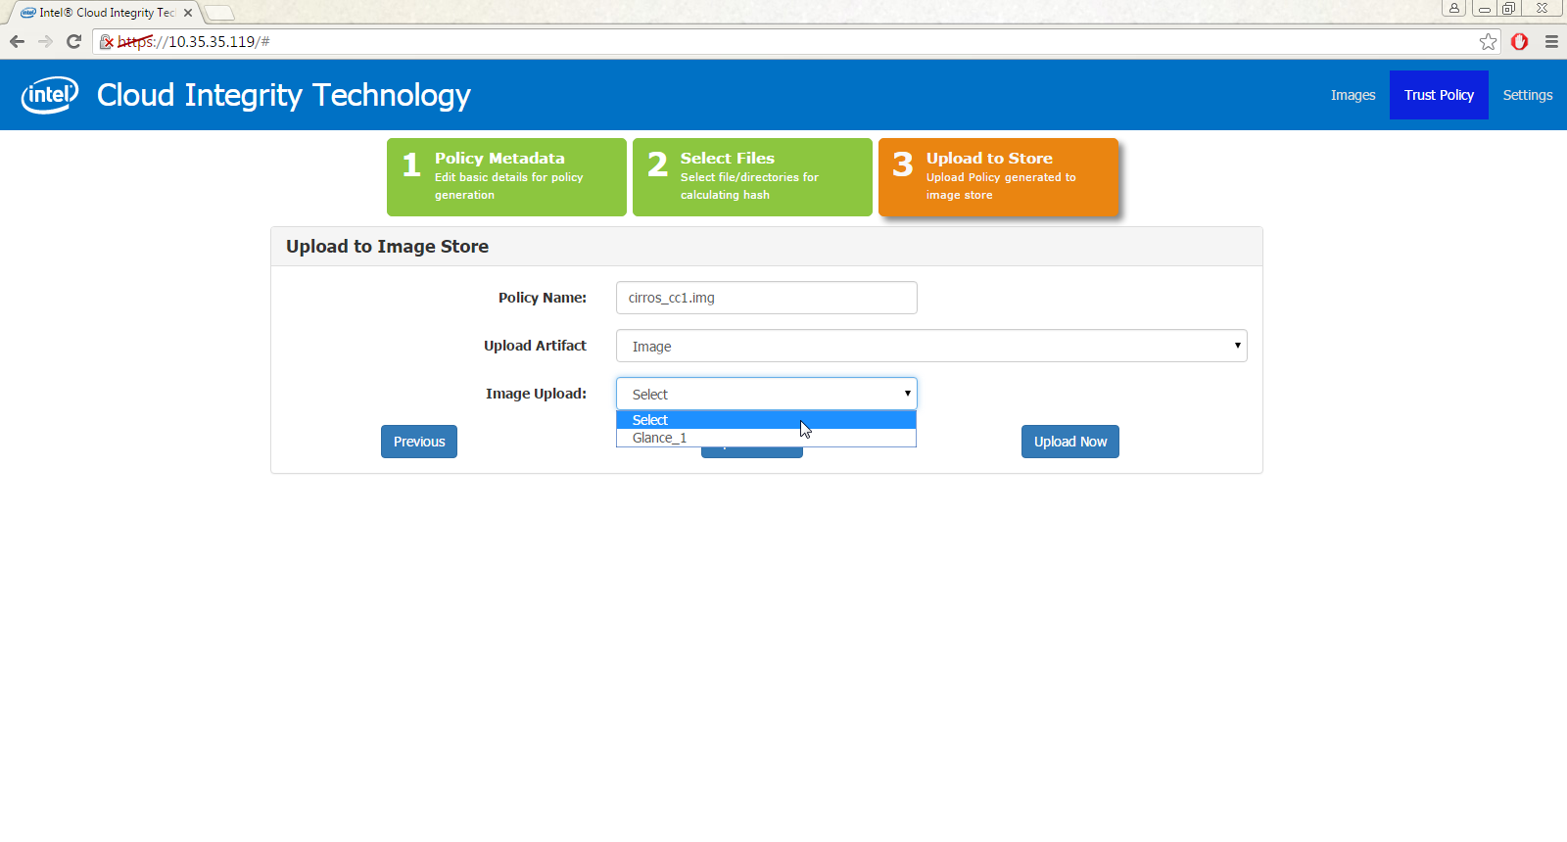

Cleanup of policies in Swift

User has uploaded image to Glance and policy to swift. For some reason the image in Glance gets deleted. Since TD does not have any way to be notified of this delete action, the policy in Swift is now an unused policy.
In cases like these we want to clean up the unused policies.

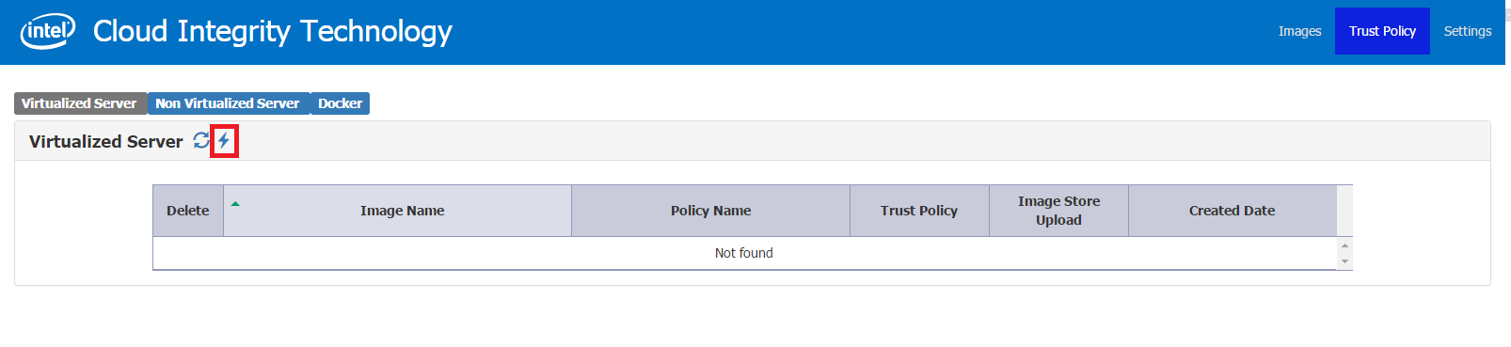
Director has “flash” icon ( open to change and suggestions on the icon ) on the VM and Docker grid pages. Clicking on this icon would trigger the cleanup task of policies in the configured swift stores.
If there are uploads yet done from TD, appropriate message is shown.
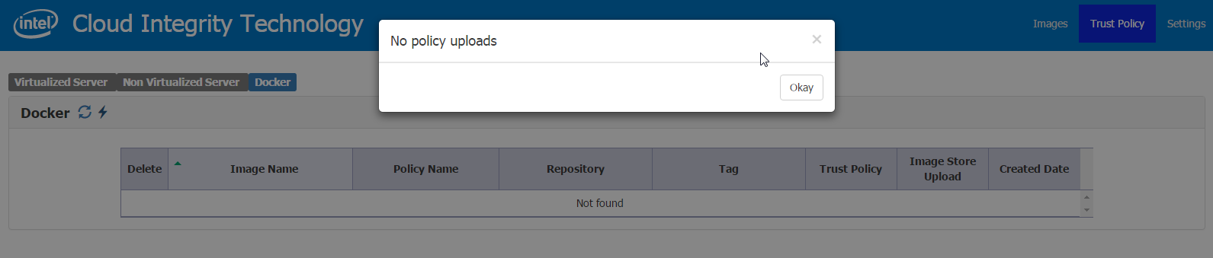

API
- https://{IP/HOST_NAME}/v1/image-stores/<UUID>
Method: GET
This method is used to retrieve the image stores that are configured in TD. If a store id is provided in the path, only the details of the store are returned.
Returns a Http 404 if no image store is found in case of an invalid UUID
- https://{IP/HOST_NAME}/v1/image-stores
Method: POST
This method is used to create a new Image store entry in TD. It creates entries in the master table for image store and entries in the details table for the key-value of the configuration required by the connector.
- https://{IP/HOST_NAME}/v1/image-stores/
Method: PUT
This method is used to update an existing image store – includes the metadata and the details.
- https://{IP/HOST_NAME}/v1/image-stores/<UUID>
Method: DELETE
When an image store id is passed, the meta data and the details for it are deleted. Returns a Http 404 in case of an invalid UUID
- https://{IP/HOST_NAME}/v1/deployment-artifacts?depolymentType=[VM/Docker]
Method: GET
- https://{IP/HOST_NAME}/v1/image-store-connectors/[Connector_Name]
Method: GET
Lists the connectors configured in TD. The valid value for Connnector_Name are Docker, Swift and Glance.
- https://{IP/HOST_NAME}/v1/image-stores/<UUID>/cleanup-policy
Method: GET
Deletes policies whose image is deleted from glance but
The response contains the name of the connector, the name of the driver class that implements it, the properties that need to be configured for it to work and the artifacts it supports.

Policy Agent

Workflow
Currently 2 use cases are supported in PA related to trustpolicy.xml location for VM scenario.
- Trustpolicy.xml as part of VM image tar ball
- Trustpolicy.xml uploaded on Swift object store
Based on the custom image property “mtwilson_trustpolicy_location” policyagent will take decision, to invoke respective trust policy retrieval module.
- If value of “mtwilson_trustpolicy_location” is “glance_image_tar” it will extract trustpolicy from the tar image uploaded to glance.
- If value of “cit_trustpolicy_location” is “swift:<object_url>”, Policyagent download trustpolicy from Swift as mentioned below:
  - It will check whether the downloaded image is tar or not. If its tar, it extract image from tarball.
  - It gets authentication token from authentication service configured with PA (Configuration needs to be provided as mentioned in above section for this. Supports Swift and Keystone based authentications). Here we use reseller admin account for authentication.
  - Using the authentication token PA downloads trustpolicy.xml from the “<object_url>” provided as part of the “mtwilson_trustpolicy_location” property/metadata of the glance image.

Configuration
New configuration added related to swift user and authentication URL
- SWIFT_AUTH_URL: Authentication URL to retrieve the authentication token.
- RESELLER_ACCOUNT: reseller_admin account of the user having access to all other accounts in swift.
- RESELLER_USER: Username of the user having access to all other accounts in swift.
- RESELLER_PASSWORD: Password of the user having access to all other accounts in swift.

B. Asset tag

Workflow
- User will create tag attributes on director
- User will get create trust policy where he will get an additional option to add tags and platform trust option in trust policy
- Director will upload image and policy and update image properties with asset tag and platform trust information
- User will launch workload, CIT scheduler filter will read properties and selects host accordingly and launch the workload
- VRTM on host verifies asset tags and platform trust from policy against one specifies in the SAML report and continue/abort launch

Trust Director

UI
Create tag Attributes

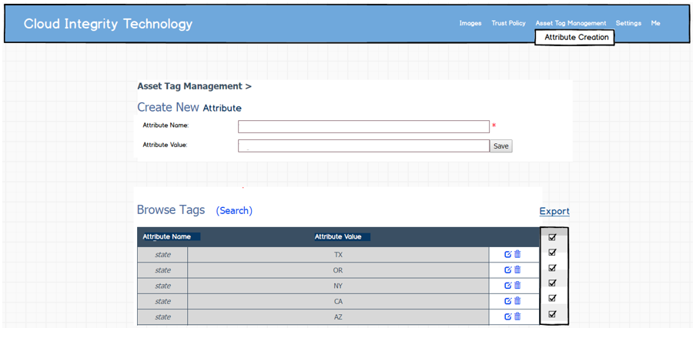
Attributes are key value pair. Director maintains its on database to store the attributes. To create new attribute user needs to enter attribute name and value pair and save it. User can browse all tags and edit or delete any specific one. User can select set of tags to export it in an xml file
Here is sample xml:
<AssetTag>
<Attribute oid="2.5.4.789.1">
<Text>country=US</Text>
</Attribute>
<Attribute oid="2.5.4.789.1">
<Text>country=INDIA</Text>
</Attribute>
</AssetTag>

Create policy metadata
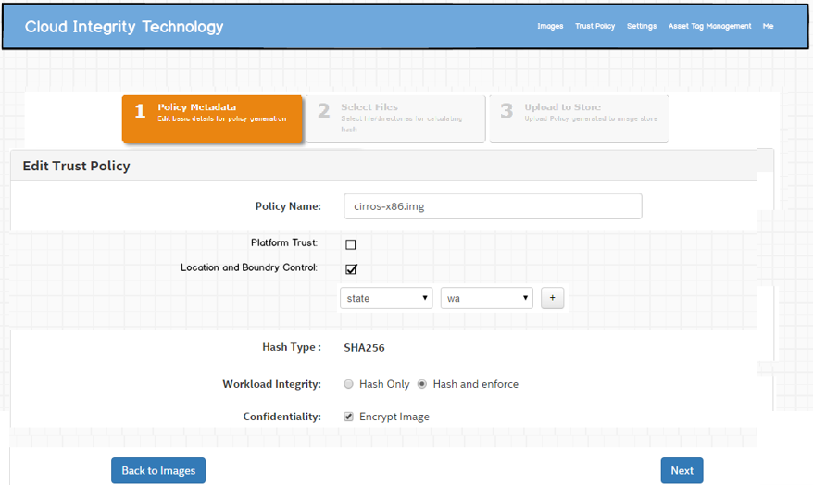

Platform Trust: If user selects platform trust the workloads will be launched on trusted host
Location and Boundary Control: If user selects this option, he will be allowed to add tag attributes in trust policy. User can add five attributes at max.
Following part needs to be added in trust policy:
<PlatformTrust>true</PlatformTrust>
<AssetTag>
<Attribute oid="2.5.4.789.1">
<Text>country=US</Text>
</Attribute>
<Attribute oid="2.5.4.789.1">
<Text>country=INDIA</Text>
</Attribute>
</AssetTag>
When director uploads policy it also updates image properties and set platformtrust and asset tags to it.
Image properties:
cit_tags = {“state": [“ca"], "state": ["wa"]}
cit_platform_trust = true

API
Reusing attestation server APIs and database code.
Resource: /tag-kv-attributes – used to manage tag attributes
POST /tag-kv-attributes
PUT /tag-kv-attributes/{id}
GET /tag-kv-attributes?criteria
DELETE /tag-kv-attributes/{id}

Openstack Scheduler Filter
CIT scheduler filter already reads image properties and process platform trust and asset tags. However, property name is changed from trust and tags to cit_platform_trust and cit_tags, which needs to be updated.

VRTM
VRTM will be updated to verify trust and tags and in trust policy against one in SAML report.

Attestation Server
Attestation server VM attestation API will be updated to verify platform_trust and tags.
- Security Threats and Mitigation
Threat Rating | Concerns/Consequence | Mitigation
Get access to read trust policy from swift  High | If an attacker reads policy from swift, it is very easy for him to figure out a way to temper the system. | Restrict swift access to just director and compute node where policy is stored
Delete image property cit_trust_policy_location | If policy location is deleted from image properties CIT would never know about existence of any policy associated | In case of openstack horizon dash board will not show the trust status.
Delete image property cit_tags or cit_platform_trust | CIT scheduler filter will not be applied and random host will be picked up to launch image | VRTM would verify entire trust policy and if it finds any mismatch, launch will be aborted
- Opens
NA

